A
PROJECT REPORT ON

“Soil Humidity Maintainer”
Submitted by,

Varun Agarwal | S184048
Deep Patel | S184051
Malay Patil | S184052

Guided by,
S.S Mhamane

A Report submitted to MIT Academy of Engineering Alandi submitted in partial fulfilment of the requirement for Fourth Semester of BACHELOR OF TECHNOLOGY in School of Computer Engineering and Technology.


SCHOOL OF COMPUTER ENGINEERING AND TECHNOLOGY
MIT Academy of Engineering
Dehu Phata, Alandi (D)
Pune - 412105, Maharashtra (India)
2018-19
  Alandi (D), Pune – 412105 | School of Computer Engineering & Technology  (Accredited by NBA, ISO 9001:2008 Certified)

CERTIFICATE

This is certify that,
Varun Agarwal | S184048
Deep Patel | S184051
Malay Patil | S184052

of S. Y. B. Tech. have submitted a Report on,

Soil Humidity Maintainer

The said work is completed by putting the requirement of hours as per prescribed curriculum during the academic year 2018 – 19. The report is submitted in the partial fulfilment of the requirements for the course Minor Project in the Fourth Semester of Degree of Engineering in –School of Computer Engineering and Technology, MIT Academy of Engineering.

Date: 25 / 04 /2019
Place:Alandi

Signature: Signature:
Name : S.S Mhamane Name : Prof. R. R. Badre
Project Advisor Dean SCET

CONTENTS
Acknowledgements |  |  | i
Abstract |  |  | ii
List of Figures |  |  | iii
List of Tables |  |  | iv
 | Introduction
 | 1.1 | Motivation
 | 1.2 | Objectives and Scope
 | 1.3 | Problem Statement
 | Literature Survey
 | System Design
 | 3.1 | Hardware Requirements
 | 3.2 | Software Requirements
 | 3.3 | Circuit Diagram (If Applicable)
 | 3.4 | Mechanical Drawing (If Applicable)
 | 3.5 | Use Case Diagram (If Applicable)
 | 3.6 | Sequence Diagram (If Applicable)
 | 3.7 | Activity Diagram (If Applicable)
 | Implementation Details
 | Results
 | Conclusion and Future scope
References

ACKNOWLEDGEMENT

We would like to express our special thanks of gratitude to the Computer Department Faculty, who gave us the golden opportunity to do this Project.
We wish to express our profound thanks to our guide, Mr.S.S Mhamane for his support, the valuable time that he spent with us, discussing our project ideas.
We also want to thank our director Dr.Yogesh Bhalerao for providing us with the basic infrastructure and other facilities.

Varun Agarwal (S184048)
Deep Patel (S184051)
Malay Patil(S184052)

ABSTRACT
The primary objective of Soil Humidity Maintainer is to help the farmers to reduce their manual work by transforming this whole process into automated one. Watering the crops by manually checking the water level everyday of different crops and giving water to the crops accordingly is a cumbersome process . Many farmers are doing suicide just because of irregular crops ,many of them do not know what crop requires what amount of water leading irregularity in their crops like many a time cases occurs when farmers mistakenly gives crop with high drought tolerance lot of water and they give less amount of water to the crop with less drought tolerance and causing a huge loss of not only money but most of the times their land as well . So if we develop such a solution so as to reduce their work and also tell them about different water requirements for different crops by checking humidity level of the soil, there comes out to be three different states that is high , medium and low required for crops with low drought tolerance , medium drought tolerance and high drought tolerance.

LIST OF FIGURES
Fig. No. | Fig. Name | Page No.
Fig 1 | Soil Moisture Percent Vs Date | 3
Fig 2 | Flowchart | 4
Fig 3 | Flowchart | 4
Fig 4 | Circuit Diagram
Fig 5 | Activity Diagram
Fig 6 | Use Case Diagram

LIST OF TABLES
Table No. | Table Name | Page No.
Table 2.1 | Required Data for Soil Moisture | 3

1.INTRODUCTION

1.1 Motivation

When I usually visit my grandfather’s village , He used to tell me about the condition of farmers due to poor crop irrigation, How my grandfather’s friends are suffering from the huge debt and how they are losing their lands and all the money they have.My grandfather tells me the important of farmers in our life , How they are responsible for nutritious and asked me to develop such a technology so it can reduce their manual work and helps them to focus more on other agricultural activities.

1.2 Objective and scope

The objective of the project is to provide a platform for farmers so that farmers can easily water their plants through their cellphones with the desired range .

The scope of the project is to familiarize farmers with the new technology and advancement so they can get best of it

1.3 Problem statement

Our problem system is to develop a system to count the humidity level and water the crop with the help of moisture sensor with the desired range.

2. LITERATURE SURVEY

QUESTIONAIRE

- Do you face any problem while watering the crops? YES/NO
- Does amount of water in the crops plays a vital role? YES/NO
- Do you want the method to be automatic ? YES/NO
- Different crops require different amount of water? YES/NO
- What if we we build the app for you so that some of your gets reduced? RELIEF/NOT NEEDED
- What do you want in the app from our side?

Results:

1) Ramprakash – YES,YES,YES,YES,RELIEF ,Automated system for watering

2) Jagdish – YES,YES,NO,YES , More languages

3) Sunil –YES,NO,YES,NO , Easy to use

4) Kantaben –NO,YES,YES,YES , Less power requirement

5) Kesari –YES,YES,YES,NO ,Accurate amount of water to be watered

Case study :
1)
Land surface temperature (LST) controls the surface heat and water exchange with the atmosphere. To parame- terize land surface processes in numerical models, information on both LST and soil moisture is needed. De tailed data analyses by Carlson and Gillies have shown that for a particular region, a unique relationship exits between soil moisture and soil temperature. A similar technique has been used by Nemani to determine surface moisture status from satellite data.
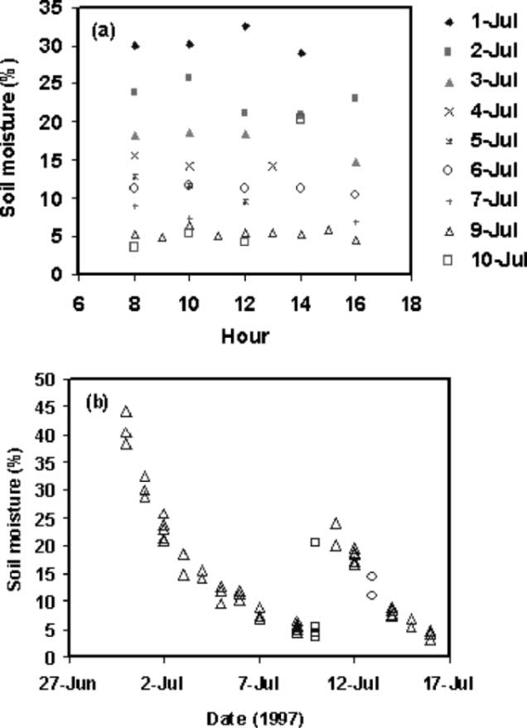
Figure 1
Sixteen days (July 1–16) during the SGP-97 experiment are used in the present analysis. Several VWC measurements during a day have been recorded at the Central Facility for site 1 (July 1–15) and for site 2 (July 1–16). There are about 2–9 irregularly spaced soil moisture observations in a day, as illustrated for selected days. During rain-free days, the diurnal variability is not strong. On July 10, based on rainfall observations recorded at this site, rainfall occurred in the afternoon causing a significant change in soil moisture content.

Table 1
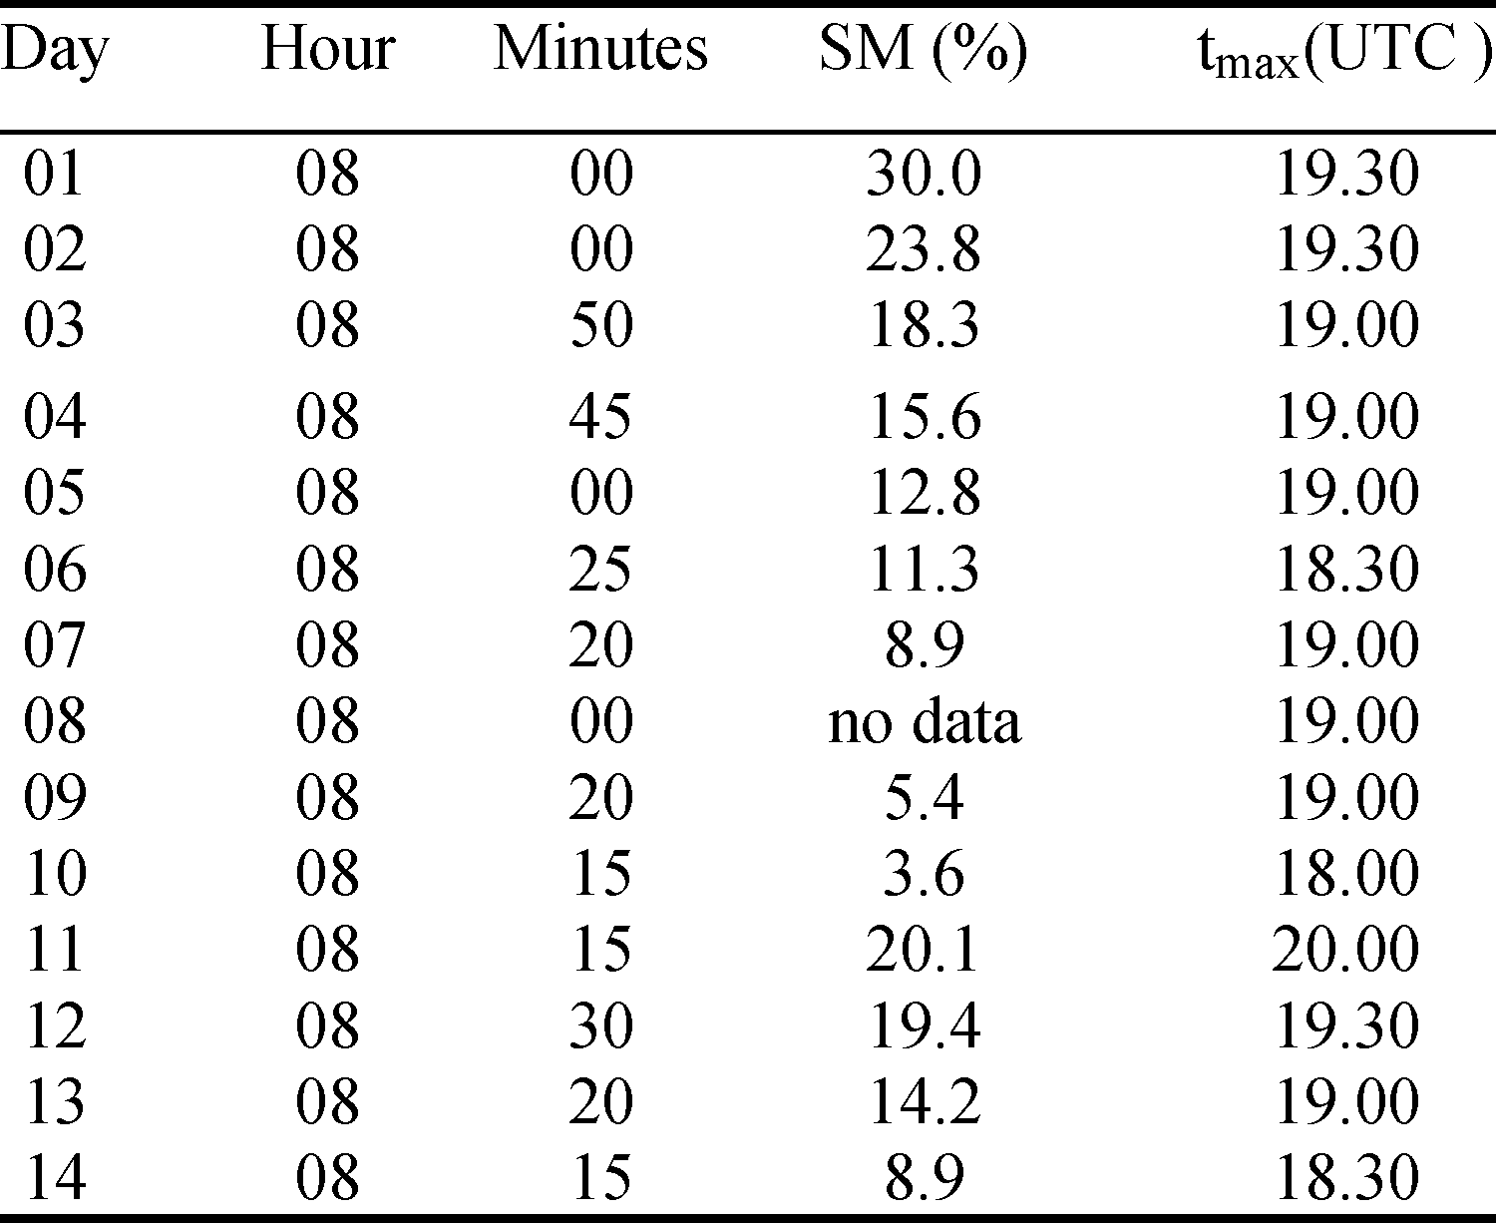

2)
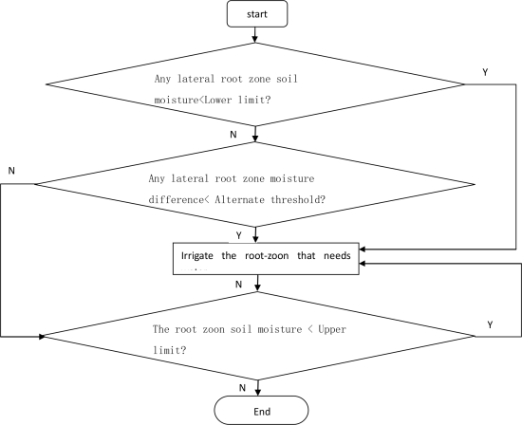
Figure 2
Control module control the motor of the irrigation system on the lateral root zone moisture difference alternate threshold, the upper/lower limit of soil moisture of the irrigated crops, and real-time information of soil moisture. When the soil moisture of root zone is below the limit, the control module controls the motor of the irrigation system start the root zone irrigation until the root zone soil moisture content is not less than the lower limit. Further determining the lateral root zone soil moisture difference whether it is below the alternate threshold, if so, the control module will control the motor of the irrigation system start to irrigate to the side which the soil moisture in the root zone is relatively low, until the soil moisture in the root zone gets to moisture maximum; If not, determine whether the soil moisture content of the root zone in which soil moisture content is relatively low is lower than the maximum soil moisture of the irrigated crops, if so, the control module controls the motor of the irrigation system start to make the relatively low soil moisture root zone irrigation, until the root zone's soil moisture gets to the upper limit of the soil moisture content.

3) India's major source of income is from agriculture sector and 70% of farmers and general people depend on the agriculture . In order to improve to the crop productivity there is an urgent need to change manual method to automation. This system should help to the farmer that provides the water to crop at stringent time and quantity. Automation irrigation system observes the moisture sensors and temperature variations of around the crop area that's gives a precise time of operation the motor turn ON and OFF.
S. Muthunpandian has given an automated system has been designed and implemented on for crop field monitoring continuously. The system maintains the water levels in the crop field at power consumption in the crop field. Developed system is useful in the irrigation system.
SOFTWARE USED : PYTHON
HARDWARE : Raspberry Pi , Soil Moisture Sensor
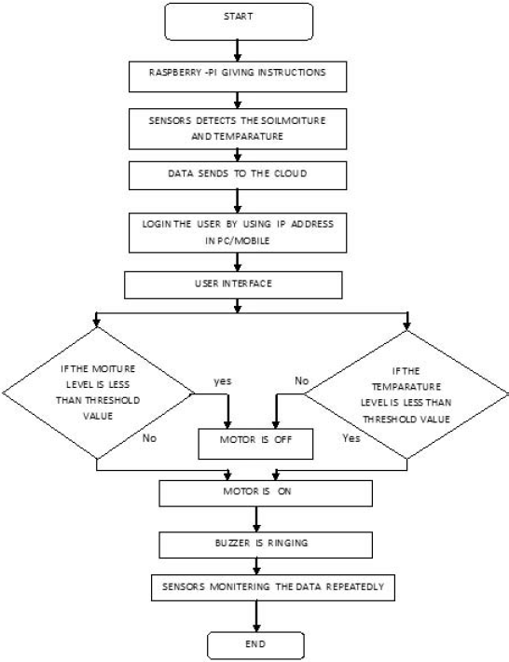
Figure 3

4) The control process of irrigation by fuzzy neural network is like this: First, the system need get the information of the water and it is transmits to the information processing unit by the sensor. The information is divided into hunger and thirst rate and transmits into fuzzy controller. The fuzzy values of input need to be converted into fuzzy variables. Using querying method and fuzzy reasoning to make the decisions, the results are considered as the fuzzy variables, and then processed by fuzzy unit, after modifying the irrigation amount; lastly, the process of the fuzzy control algorithm is finished. The irrigation control based on fuzzy neural network is optimum output which is obtained by trained network and calculation. This kind of control mode reacts quickly, further, the neural network has the capability of self learning and associating, so it can make the decision by the capability of the associating for the samples that never appeared in the training samples.

3)System Design
3.1 Hardware Requirements
- Moisture Sensor Module
- Arduino Uno
- Motor
3.2 Software Requirements
- Arduino IDE

3.3 Circuit Diagram

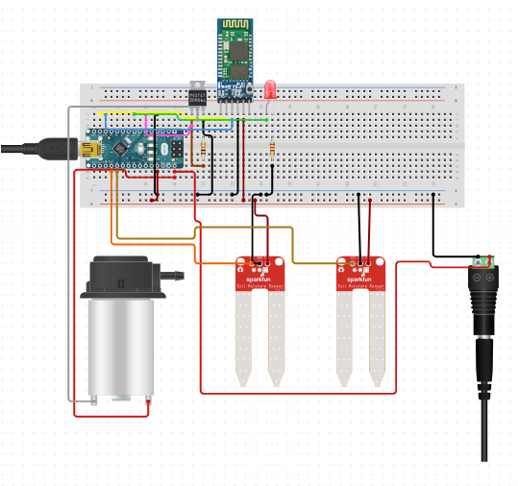
Figure 4

3.4 Activity Diagram

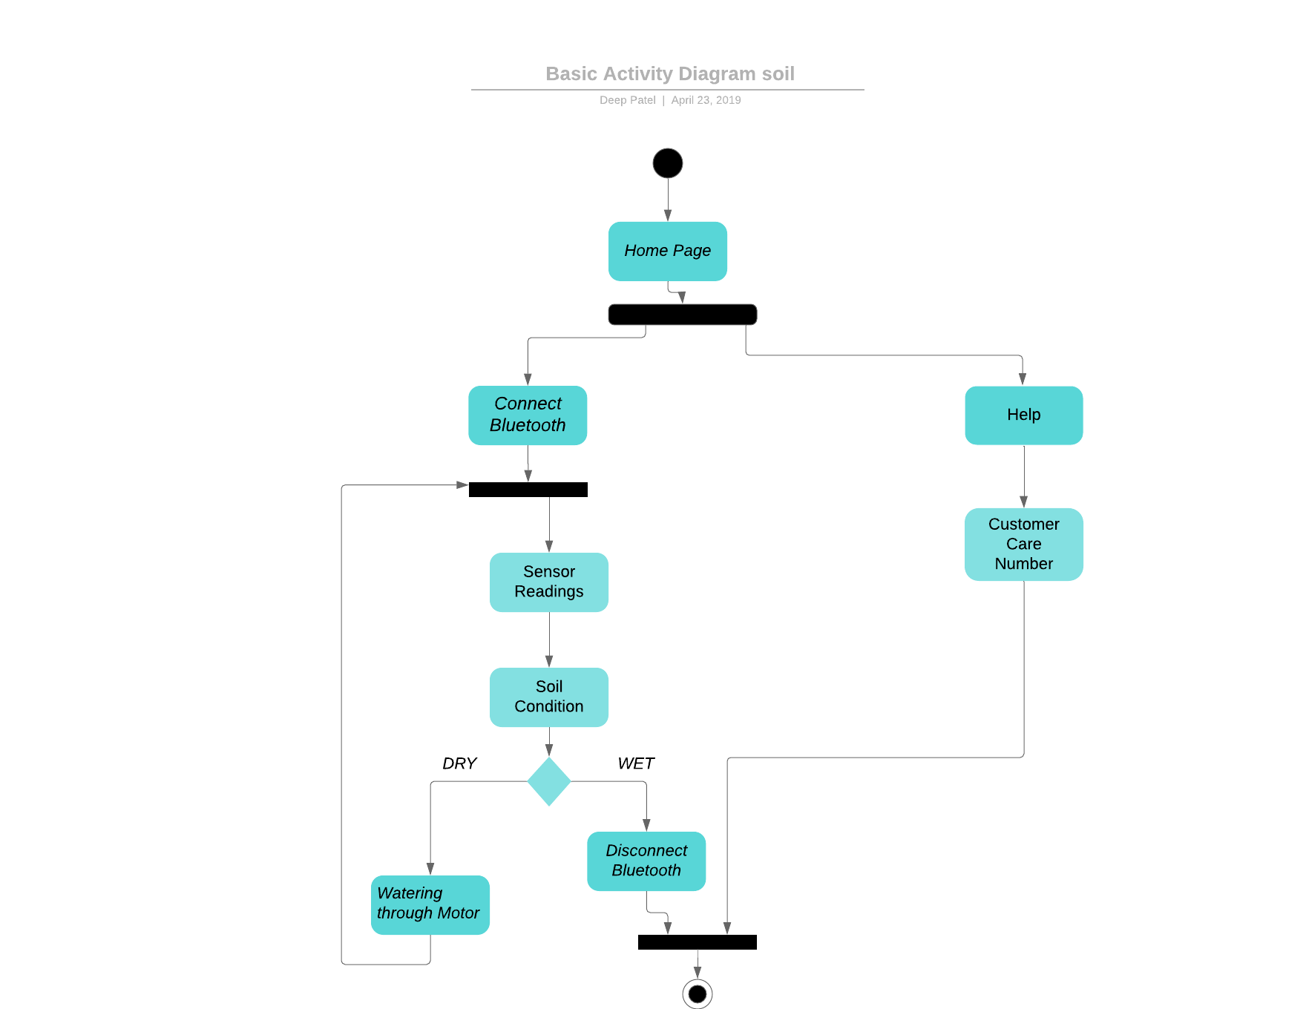
Figure 5

3.5 Use Case Diagram

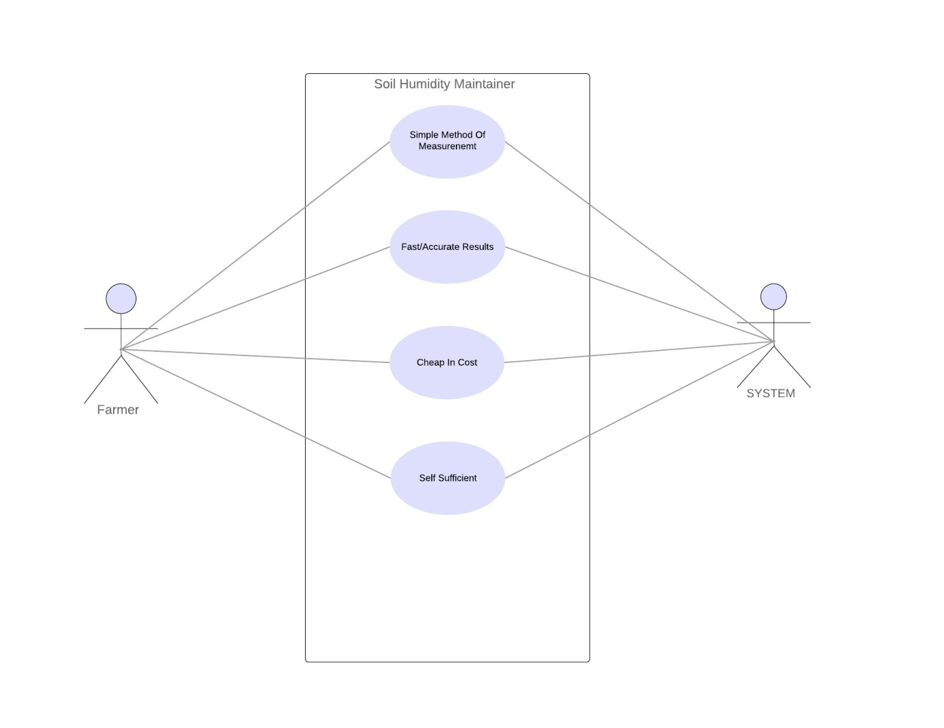
Figure 6

4. Implementation Details
This project is divided in two parts 1. Circuit 2. Application
- Circuit :
- The circuit consist of 2 moisture sensors(YL-69) which measures the voltage between 0V to 5V in 10 bit (1024 steps).
- With the help of HC-05 the readings are measures and send to the application.
- One motor is also included with relay to pump the water according to the conditions of the soil.
- Application:
- On the home page of application there is a button of help which shows instruction for using app in two different languages Hindi and English.

Result :

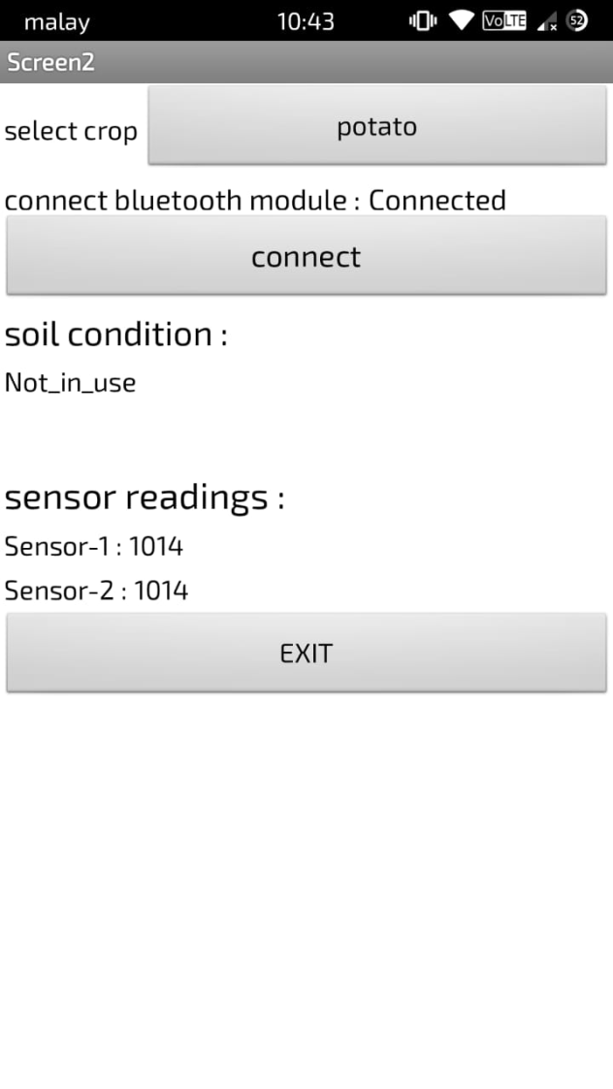

References :
https://www.vernier.com/products/sensors/sms-bta/
http://www.circuitstoday.com/arduino-soil-moisture-sensor
https://www.agroengineering.org/index.php/jae/article/view/560/572
https://patch.com/minnesota/edina/bp--consider-these-heat-drought-tolerant-vegetables-f7d7816f372
https://www.youthkiawaaz.com/2018/05/agricultural-issues-in-india-problems-faced-by-farmer/

